CSC373 – Tutorial 2

* Note – Starting next week we will be meeting in room SS2118!
* Assignment 1 is out; due June 8 11:55(:00) pm

15.4 – 6

Array $A$ of integers $Θ\left(n\log{n}\right)$

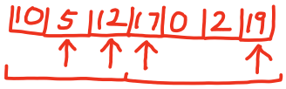

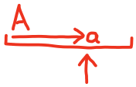

$L\left[i\right]=\text{smallest last element in any subsequence of length}$

$B\left[i\right]=\text{subsequence of length} i \text{with the smallest last element}$

$a$ into list 2

for the $i$ such that

$L\left[i-1\right]<L\left[i\right]<a≤L\left[i+1\right]$

$↑$

Set $B\left[i+1\right]=B\left[i\right]+\left\{a\right\}$

Set $L\left[i+1\right]=a$

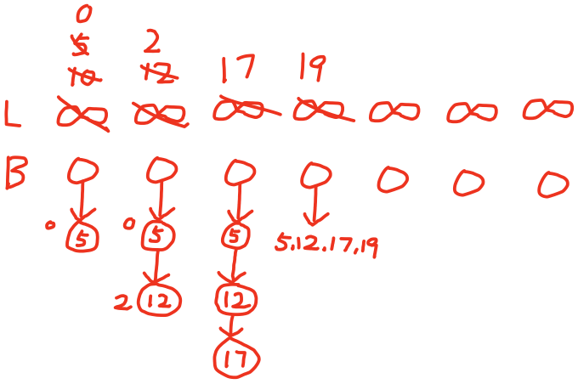

Company

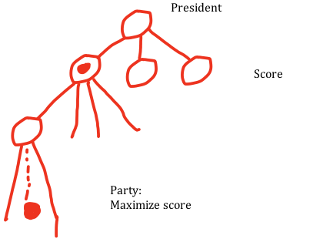

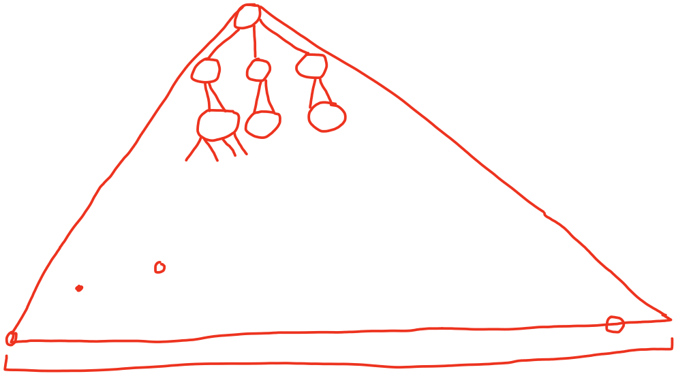

$Σ$ +Account

- Children

|  |  |  |  |
| --- | --- | --- | --- |
|  |  |  |  |
|  |  |  | + Account  - Children |
|  |  |  |
|  |  |  |

|  |  |  |  |
| --- | --- | --- | --- |
|  |  |  |  |